**EDUCATIONAL ORGANISATION USING SERVICENOW**

# **TEAM INFORMATION**

**NM_ID :** 6A21652EE6E038393B844F76131EAD0D

**Team ID** **:** NM2025TMID15870

**Team Size**  **:** 4

**Team Leader** **:** R DEVIKA

**TEAM MEMBERS**  
1. C GAYATHRI  
2. T SHANMUGA PRIYA  
3. M KOKILA

**PROBLEM STATEMENT**

Educational institutions often face challenges in managing their administrative, academic, and support services efficiently. Processes such as student onboarding, faculty support, IT service requests, and facility management are typically handled manually or through disconnected systems, leading to delays, miscommunication, and lack of transparency.

Without a centralized platform, students struggle with delayed responses to queries, faculty face inefficiencies in handling academic requests, and administrative staff lack real-time visibility into service requests.

# **OBJECTIVE**

The main objective of implementing ServiceNow in an educational organization is to streamline and automate academic, administrative, and IT service processes to improve overall efficiency and user experience. Centralize Service Management, Enhance User Experience, Automate Workflows, Improve Communication & Transparency, Data-Driven Decision Making, Increase Efficiency & Productivity.

**SKILLS:**

* Problem-Solving Skills (designing solutions for educational service requests)
* Analytical Thinking (understanding requirements and mapping to ServiceNow features)
* Communication & Collaboration (working with faculty, staff, and students for requirements)
* Project Management (organizing tasks, timelines, and deliverables)

**STEPS TO COMPLETE THE PROJECT:**

**Setting Up ServiceNow Instance**

1. Sign up for a developer.servicenow.com
2. Click on “Request Instance”.
3. Fill out the required information and submit the request.
4. Login to your ServiceNow instance using the provided Credentials.

**Creating A Update Set**

1. Click on All >> Local update sets.
2. 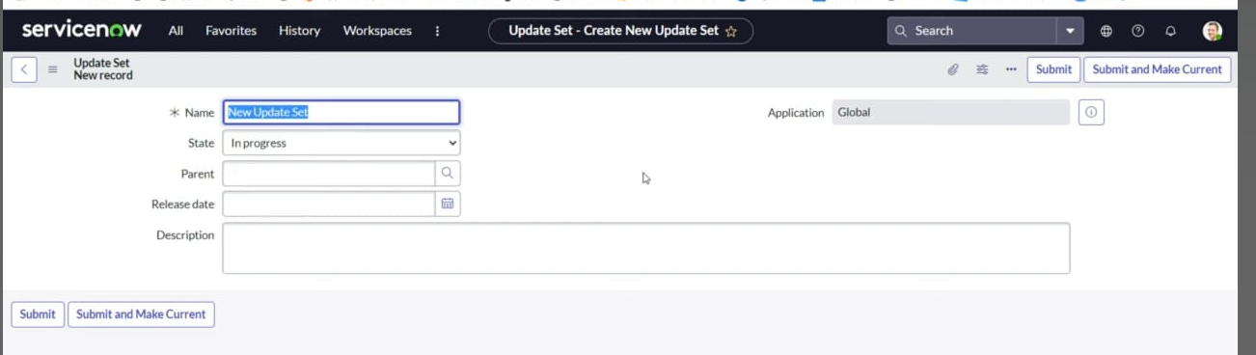Enter the Details Name: Educational Organisation >> Click on Submit.

**Create A Table**

1. All >> Tables and Click New button.
2. Enter the Label, Name
3. Enter the values and Label on column “Grade, Admin Number, Admin Date, Father Cell, Father Name…
4. 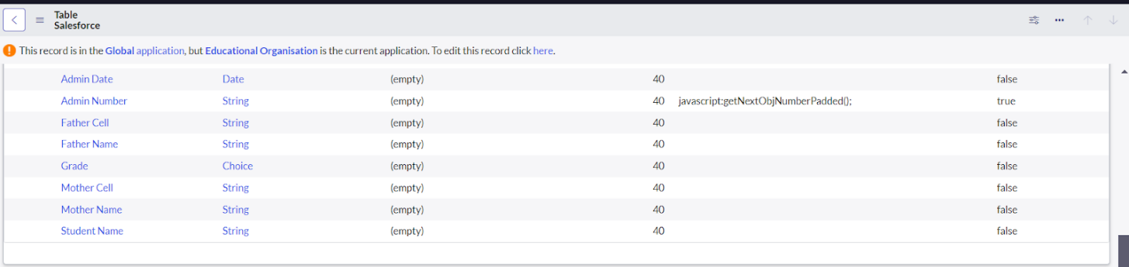Click on controls >> Enable extensible.

**Form Design**

* Creating Form Design For Saleforce Table:

1. All >> System Definition >> Tables.
2. Label Search for Salesforce and open Right Click >> Configure >> Form Design
3. Select Salesforce(u_salesforce).----------------
4. Drop the fields and Save.

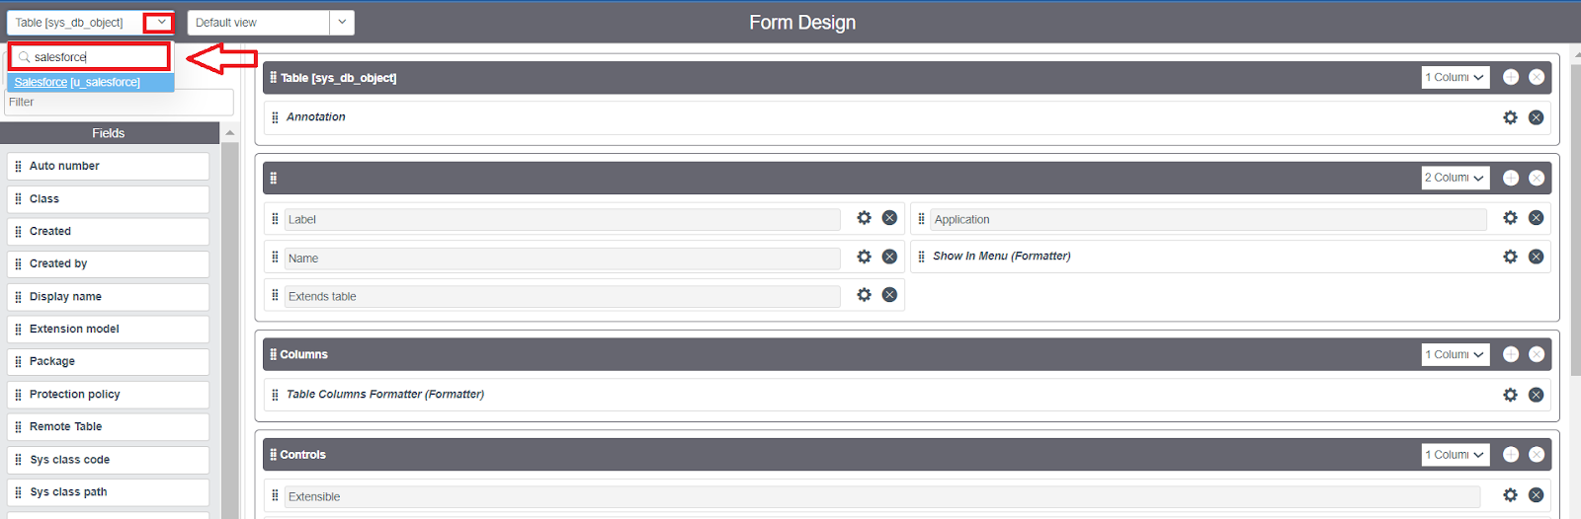

* Creating Form Design For Admission Table and Creating Form Design For Student Progress Table

1. Follo the same steps as Activity 1 for this two task and complete it.

**Number Maintenance For Admin Number**

1. 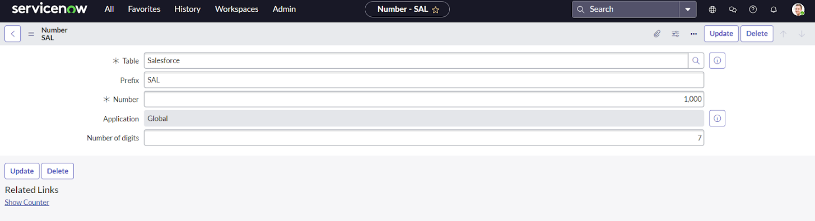All >> Number Maintenance >> New Fill the Details and Submit.

**Process Flow For Admission Table**

1. All >> Process Flow >> New and Fill the Details.
2. 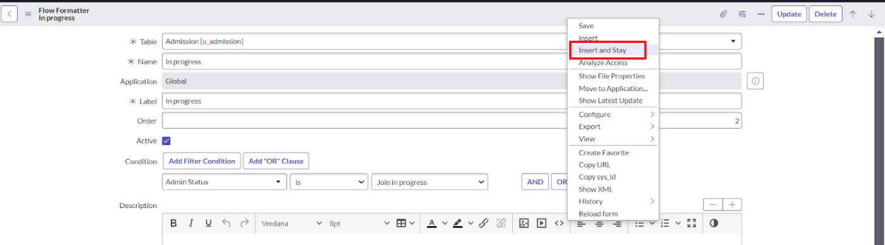Save it and Replace the Name and Label as Joined, Rejected, Rejoined, Closed, Cancelled, New, Join In Progress by using Insert and Stay.

**Client Script**

* Creating “Auto Populate” Client Script For Admission Table

1. All >> Client Scripts >> New and Fill the Details.
2. Write the Code and Save it
3. Follow the same steps for upcoming task Pincode Update, Disable Fields, Total Update, Result, Percentage.

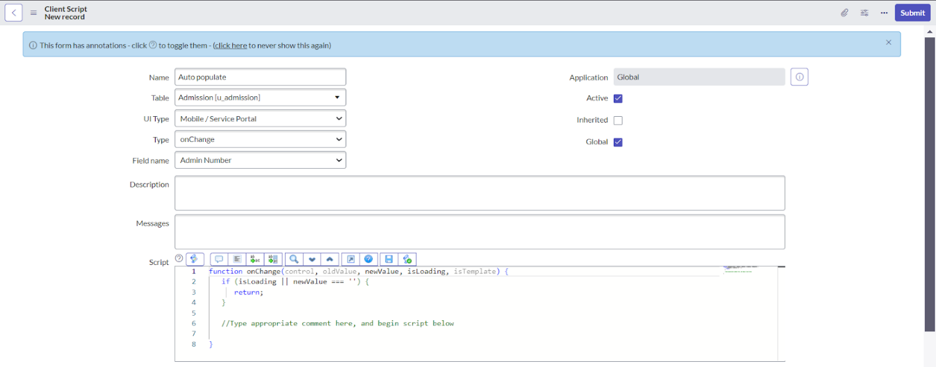

**CONCLUSION:**

The project “Educational Organization using ServiceNow” successfully demonstrates how the ServiceNow platform can be applied to streamline and digitalize academic and administrative processes within an educational institution. By implementing catalog items, workflows, and knowledge management, the project provides students, faculty, and staff with a user-friendly system for handling requests efficiently. It reduces manual efforts, improves transparency, and ensures faster resolution of academic and non-academic services. Overall, this project highlights the effectiveness of ServiceNow as a powerful tool to enhance service delivery and operational efficiency in the education sector.